RUNWELL ROUNDABOUT
WINTER EDITION 2014
RUNWELL ROUNDABOUT is sponsored by Runwell Parish Council keeping you informed about issues affecting Runwell Residents
THE SEASONS GREETINGS FROM ALL OF US TO ALL OF YOU
AND A HEALTHY 2015
Every effort is made to ensure the information in this newsletter is correct. The Parish Council cannot accept any liability for errors or omissions. Views and opinions expressed in this edition are not necessarily those of the Runwell Parish Council.
Runwell Allotments get Big Lottery funding for “Green Loo”

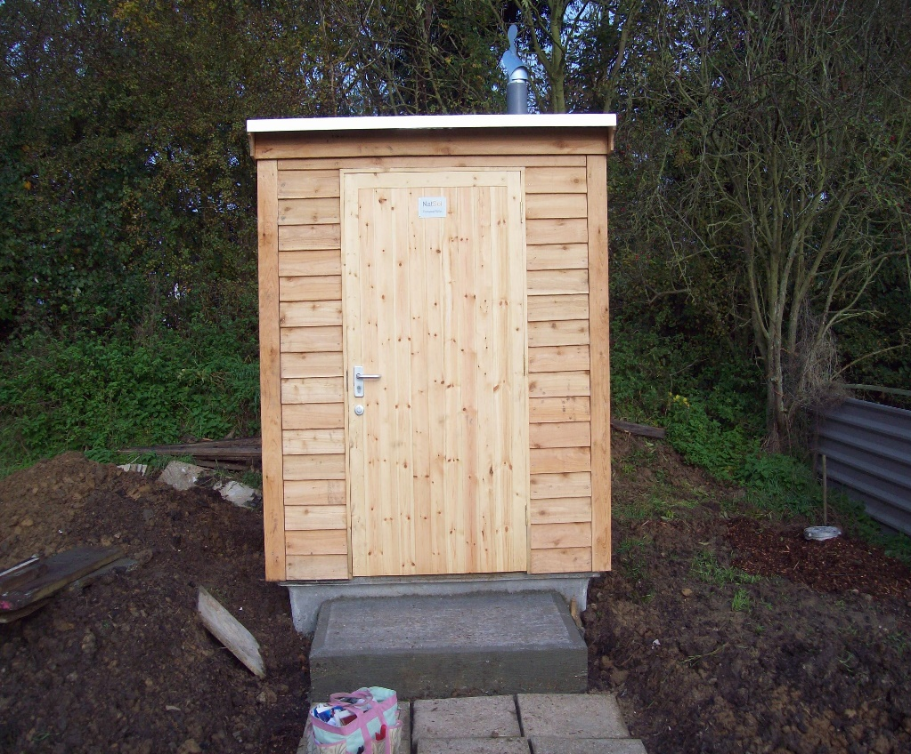
The installation is nearly complete just the landscaping to complete!

Runwell Allotment Association are flushed with success following a successful grant award from the Big Lottery for their “Green Loo” project – a self-composting toilet. Their thanks go to Runwell Parish Council for help with the planning and application process, Jim Pearce for storing and transporting the unit, MC & S Builders for the installation, Natsol the manufacturers and to all the volunteers from the allotments group who helped with preparing the site and finally not forgetting Linda Payne who got the project off the ground and organized everything along the way!

(The toilets at Scotland Yard were stolen last week. Police have nothing to go on.)

From the Chairman of Runwell Parish Council:

We are now half way through the current financial year 2014/15 and I am pleased to report that the financial aspects of Runwell Parish Council are in good hands and likely to be on target for the current year.
We now need to establish a budget for the period starting in April 2015 and completing in 18 months’ time. This amount will be included in the many factions which make up the total amount which will appear as ‘Housing Tax’ and is known as the Parish or Penny Rate. This money collected is spent in the immediate area for the direct benefit of Runwell and can be used for anything seen as important to the locality. The money collected is allocated by your Parish Council in the best way to back-up local services in a small way, rather than replace major spending by the big hitters at City or County Hall. Our ‘Penny Rate’ when added together from all the homes amounts to about £62k so the activities have to be somewhat modest in scope. However what is achieved is highly cost effective and the returns to the community are about 3 times more ‘bang for your buck’, if the same work was carried out by one of our larger cousins.
This year Central Government reduced the ‘Rate support Grant’ so our very small part will be smaller so that it will be necessary to concentrate our efforts to ensure services are maintained. With the former Runwell Hospital site being developed over the next few years, one aspect is that with the increase in housing stock the Penny Rate will increase allowing broader support to the local community without increasing the individual contributions.
Turning to more pressing matters; we along with the City, County and river Authorities we have been assessing how we can best prevent a re-occurrence of the flooding in Church End Lane. A very recent review of the causes and affects has highlighted that this somewhat modest brook drains a very large proportion of Brock Hill. It is quite clear that the watercourse even if it is being well maintained is inadequate to cope with flash flooding on the flank of the raised ground behind the Village. The basic problem is that raised ground is feeding water on to a near level stretch where it immediately slows and cannot flow away at a sufficient speed to prevent levels increasing. At present the problem is mainly seen in the Meadow Lane / Church End Lane area but any relief in those areas must produce a higher flow rate to the rear of the Quart Pot and until the higher volume of flood water is channelled well clear of the Brick Cottages, Runwell Road this proportion of the Village will become affected when these conditions occur. (We have also experienced flash flooding problems on the A132 Runwell Road close to this point) It is on this basis, that we along with our representatives from Chelmsford City Council will be pressing Essex County Council and Environment Agency (formerly the River Authority) to improve the capacity of the drainage system within the built up area/s of the Village.
On behalf of Runwell Parish Council I wish you all a Happy Christmas and a safe and fruitful New Year. Bill Lansdale

A couple of thoughts:
I always take life with a pinch of salt; plus a slice of lemon and a shot of tequila.

If at first you don’t succeed, give up on the thought of going sky-diving!
Essex County Council Mid Area Highways are responsible for the maintenance of the roads and footpaths in Runwell. (To report defects 0845 703 7631 or hazards 0845 603 7631.)

MORE NEWS FROM THE ALLOTMENTS – It has been an amazing year, everything grown has done very well so we had a bumper harvest. We now have 10 beehives, the bees are thriving and we have just had our first Runwell Honey (it’s great!); it’s called “Broadland Honey” the beekeeper is Mr. Colby-Blake from Southend. At the moment there are a few vacant plots, so, if you like to enjoy the fresh air, keep fit, and have lovely fresh fruit and vegetables, put your name down for an allotment. Contact Linda 01268 732033.

RUNWELL PARISH COUNCIL ELECTIONS MAY 2015
If you have a few hours to spare and would like to get involved in your community then look out for more information in the 2015 Spring Edition of the Runwell Roundabout for how to become a Parish Councillor or e-mail jo@runwellpc.wanadoo.co.uk www.essexinfo.net/runwell-parish-council

Local Policing: Our local WPCSO Hilary Wilmott no longer attends the monthly parish council meetings. There has been a change of policy and now if you wish to speak to Hilary or the officer on duty you have to see her at a “Street Meeting”
Date: | 9th December 2014 09.00 – 10.00  29th December 2014 14:00 - 15:00
Where: | Runwell Village Hall  Church End Lane  Runwell  SS11 7JE
Extra Info: | This is your chance to speak to your local PCSO in regards to any Local Policing issues you may have or for any crime prevention advice.
Contact: | Email: hilary.willmot@essex.pnn.police.uk
Please follow this link for future meetings:
https://www.essex.police.uk/my_neighbourhood/chelmsford_district/chelmsford_rural_south/chelmsford_rural_south-2.aspx

There have been a number of burglaries in Runwell recently please be vigilant if you see anything unusual please report to the NON URGENT Police telephone number 101

BEAT THE BURGLARS: LOCK THEM OUT - DON’T LEAVE VALUABLES OR CHRISTMAS PRESENTS ON DISPLAY; DON’T LEAVE CARDBOARD BOXES FOR HIGH VALUE GOODS OUTSIDE; DOUBLE CHECK WINDOWS AND DOORS ARE LOCKED; DON’T ADVERTISE YOUR ABSENCE; SET AN ALARM IF POSSIBLE.

For more information www.chelmsford.gov.uk/communitysafety call 01245 606477

Infill: I got a new horse for my wife…. Best swap I ever made!!!!!

BOXING DAY WALK

ALL ARE WELCOME TO THE BOXING DAY WALK – If you would like to do something different this Boxing Day why not come along to the 40th walk. The walk takes about 2 - 2 ¼hrs and is around 4 – 4 ½ miles start to finish – we always visit “The Running Well”. I have been using the Public Footpaths now for 60years.(also known as PRoW’s)
MEET at RUNWELL PARK in the Car Park at 10.30am on 26th December 2014 come rain, sleet or snow!!! If wet don’t forget your wellies or other suitable footwear.

A Happy & Merry Christmas to all David De’ath (Walk Leader)

Burn fat, get fit & have fun…..

Our fun, friendly, easy to follow diet and fitness class will help you to get fitter, increase your energy levels, lose weight and tone up at your pace. Suitable for ages 18-80+ - come along and join the fun!
Monday 10am - 11.30am diet & exercise (exercise only welcome too 10.30-11.30am)
Class includes optional weigh in and health/fitness related talk
Runwell Village Hall, Church End Lane,
Class fee just £5.50 per week
For more information or to book your space contact Kate West
fully qualified & insured instructor 10+ years experience
Tel: 01277 651185 Mob: 07932 691419
E-mail: kate1.west@talktalk.net Facebook at Get in Shape with Kate.

RUNWELL VILLAGE HALL FOR HIRE Church End Lane, Runwell SS11 7JE
Weddings, Dinner Dances, Dances, Parties, Quiz nights, Bazaars or Meetings All Enquiries & Bookings to: - Mrs Jo Pharez Clerk to the Council Tel: 01268 735152 or email jo@runwellpc.wanadoo.co.uk

