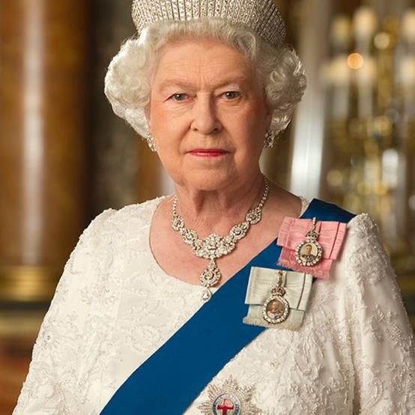

Her Majesty Queen Elizabeth II
21st April 1926 - 8th September 2022
from Runwell Parish Council
" It is with great sadness that Runwell Parish Council acknowledges the passing of Her Majesty Queen Elizabeth II. The Parish Council sends our deepest condolences to the Royal Family at this time, who are all in our thoughts and prayers.
Her Majesty Queen Elizabeth II has been a pillar of strength, stability, and shown a great work ethic
throughout her 70-year reign.
A Book of Condolence is available for residents at St. Mary's Church, Runwell Road (9am to 5pm and 7pm to 9pm) on Saturday 10th September. From Sunday 11th September until the State Funeral, the Book of Condolences will be available at Runwell Village Hall SS11 7JE between 9am - 4pm.
If you prefer online go direct to https://www.royal.uk/
St. Mary's Church will be holding a Commemoration Service on Friday September 16th at 7.30pm.
Floral tributes can be left at the foot of the flagpole at the Village Hall, Church End Lane.

Cllr. Paul Clark
Chairman
Runwell Parish Council

